Mandarin Go 中華文化活動工作坊

【BH兒童華語工作坊】第一場活動紀錄

#### 中文版

Mandarin Go 與 Burgh House & Hampstead Museum 在四月二十六日迎來第一場兒童中華文化活動工作坊。以「春天來了」為主題，結合創意水墨畫，工作坊在具有三百年歷史的博物館禮堂舉辦。優雅精緻的木製空間，迴盪《春天來了》童謠，吸引了來自四面八方的家長帶著孩子來參與，現場歡笑聲不斷。

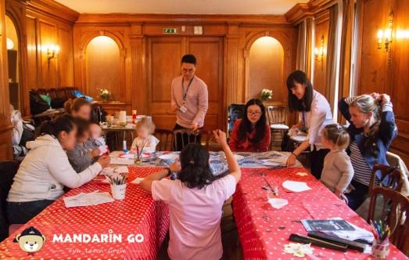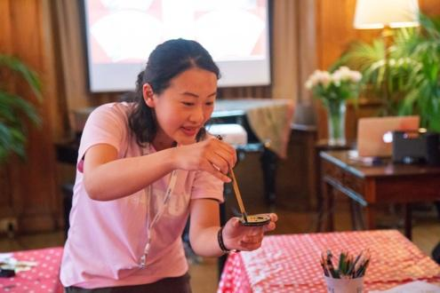

Mandarin Go 的「中華文化活動工作坊」集合了教學經驗豐富的教師，歷經與館方長達三個月的協商與合作，成功籌劃連續三個月的系列工作坊。從中華文化、漢字體驗、創意美感等角度發想，第一場工作坊搭配百花盛開的時節、場景，以「春天來了」的概念設計這次工作坊。

教師以親手自製的花瓣、蝴蝶、蜜蜂，引導孩子們從色彩繽紛的道具中，認識花、鳥、春天等字彙，孩子們愉快隨著童謠節奏跟唱。Mandarin Go 特地準備中華傳統毛筆與墨水，讓孩子感受獨特的毛筆繪畫初體驗，小小的手在精美的扇形宣紙上，舞出既柔軟又有韌性的筆觸，一株株形狀、大小各異的樹枝躍然紙上。

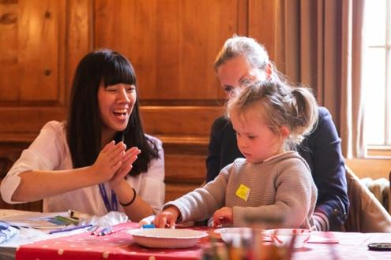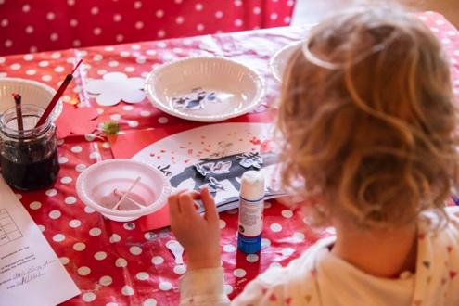

臨近工作坊結束前，孩子們用棉花棒沾上紅色顏料，為自己手繪的樹木妝點一朵朵鮮美的花，以及剪貼預先準備好的百鳥和字彙剪紙。當孩子興奮地逐一和自己充滿童趣的成品合照時，家長們也回饋「這裡的老師都相當專業與親切」、「我的小孩玩得很開心，還能夠從歌謠、手工藝中學到了中文」，紛紛詢問下次活動的資訊，期盼參加未來 Mandarin Go 所舉辦的工作坊及兒童華語課程。

#### English Edition

On the 26th of April 2019, Mandarin Go Ltd. held its first Chinese language and cultural workshop in collaboration with Burgh House. This event was themed “Spring" to welcome the season to London and involved activities such as Chinese ink painting and singing. The event filled Burgh House’s beautiful, historic hall with children’s laughter and created an immersive learning atmosphere.

The workshop was the first of a series, and was the result of three month of work between Mandarin Go Ltd. and Burgh House. Our team on the day comprised on three experienced teachers and one photographer, all working with the goal of integrating Chinese culture, Chinese characters, art, and creativity into the workshop.

Children present learned some interesting Chinese characters such as spring (春), bird (鳥), flower (花) through songs, arts and crafts. They also enjoyed drawing their own Chinese ink paintings through Chinese calligraphy. This meaningful memory was captured on their unique artworks.

“Teachers are friendly and professional, we enjoyed the play, songs, art, and crafts to learn Mandarin”, “The event is great, and we hope that there is more event like this in the future”, were some of the feedback we received from the parents! We’re very grateful to have this opportunity to interact with the children and their parents, and we would like to thank the team at Burgh House & Hampstead Museum for the opportunity received.

#### Facebook posts by Khai. 1st May 2019.

Post 1

On 26th April, we hosted our first Chinese language and cultural workshop for children at Burgh House & Hampstead Museum! It’s the first out of a series of three workshops we will be holding with Burgh House, part of a long term collaboration between us.

Thank you for everyone who join us last Friday! See you on 24th May 1600-1700 @ Burgh House for the next workshop :)

##### Post 2

“Teachers are friendly and professional, we enjoyed the play, songs, art, and crafts to learn Mandarin”, “The event is great, and we hope that there is more event like this in the future”, were some of the feedback we received from the parents!

We’re very grateful to have this opportunity to interact with the children and their parents, and we would like to thank the team at Burgh House & Hampstead Museum for the opportunity received.

Interested in our next workshop? Sign up now! **{{add sign up link}}**

##### 

##### Post 3

EXCITED for the next event? Mandarin Go’s next workshop is just around the corner and we have an exciting present for one lucky child joining us on 24th May!

Try to guess what the prize might be ;) and we’ll be posting the theme for our next workshop soon! Like our facebook page to stay updated on our events and competitions.